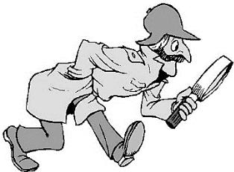**THE CASE OF THE MISSING COMPUTER CHIP (IT'S PLUM CRAZY TO STEAL FROM US)**

*Use your observation skills to solve this crime!*

**INTRODUCTION:**

It's the morning of July 5 in the northern California city of Cupertino. You are working the burglary watch, day shift. As commander of the electronic theft division you have a team of experts, skilled in the collection of all types of evidence relating to theft of computers and electronic stuff. At 9:50 a.m. you get a call that someone has attempted to steal an advanced chip from the Plum Computer Company. You and your team respond immediately to the call. When you arrive, you find that the plant is sealed off and all the uniformed employees in the plant have been confined to a single room, the lounge. Within the hour, the missing chip is found in an envelope in a pile of mail. The envelope was addressed to Gordon Lidy, the security chief of a rival computer firm. A cassette tape was also found in the envelope.

You assign one of your best officers, JoAnn Lane, to interview everyone present. Here is what she finds:

**A**. Steve Randak, the president, arrived at 8:50 this a.m. to find the tone-operated security door to his privatelab open and the prototype of his new computer chip missing. He immediately pushed the panic button that alerts security to close the gates. The guard at the gate reported that no person had left the plant since 8:00 a.m. today.

**B**. Jo Ann begins accumulating clues, and as she does, tries to develop a hypothesis for how it was done, andwho did it. She keeps her clues in an envelope.

Evidence: Write down the clues which help prove your person is the thief



Claim: Who do you believe stole the Computer Chip?

Reasoning: Why does that clue help prove your claim?

Evidence 1:

Evidence 2:

Evidence 3:

Write your CER in a paragraph form

__________________________________________________________________________________________________________________________________________________________________________________________________________________________________________________________________________________________________________________________________________________________________________________________________________________________________________________________________________________________________________________________________________________________________________________________________________________________________________________________________________________________________________________________________________________________________________________________________________________________________________________________________________________________________________________________________________________________________________________________________________________________________________________________________________